Agentic AI

Topic: Multi-File AI Collaboration using Cline

Introduction:
Good morning everyone!
Artificial Intelligence has moved from just giving answers to actually making decisions. This new era is called Agentic AI — where AI systems act like intelligent agents, capable of planning and executing tasks. Today, we’ll explore how tools like Cline make this possible for programmers.
By the end of this session, you’ll understand how agentic AI and tools like Cline are changing the way we program and build intelligent systems.

Installation and workflow:
Installation:
- Open VS Code.
- Go to Extensions → search “Cline”.
- Click Install.
- Connect it with an AI model (like GPT or Claude).
Workflow:
- Open your project in VS Code.
- Chat with Cline to explore or edit code.
- Cline can create, modify, explain, or debug multiple files.
- Review and approve every AI-generated change.
- Use it to generate tests, refactor code, and add documentation easily.
- It also tracks your project context, so AI understands the whole codebase before making changes.
Conclusion:
Cline turns VS Code into a smart coding partner, saving time and improving accuracy in every step of development.

Cline interface look like that:
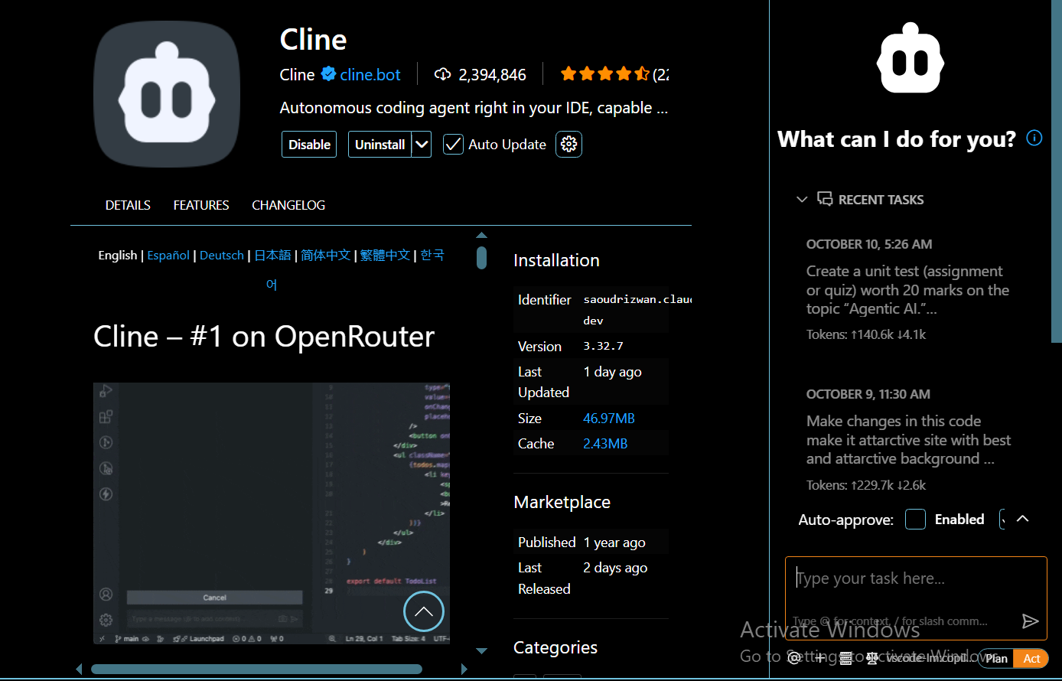
Next we have to just singin with Cline by using our google account or using Github account.
Now we have successfully connected our VS code with AI AGENT cline.
key functions:
• CLINE Tab – Switch between normal AI chat and Cline’s project-based coding mode.
• Recent Tasks – Shows your past AI commands or code tasks for quick reuse.
• Auto-approve – When Enabled, lets Cline apply safe code changes automatically.
• Read / Edit – Grants AI permission to read or modify your project files.
• Edit (all), Safe Commands, All Commands, Browser, MCP – Control what types of actions the AI can perform.
• Task Input Box – Type your coding tasks or prompts here to interact with Cline.
• Model Indicator (bottom left) – Shows which AI model (e.g., GPT-4) is being used.
• Settings / Icons (top right) – Access configuration, account, and help option.

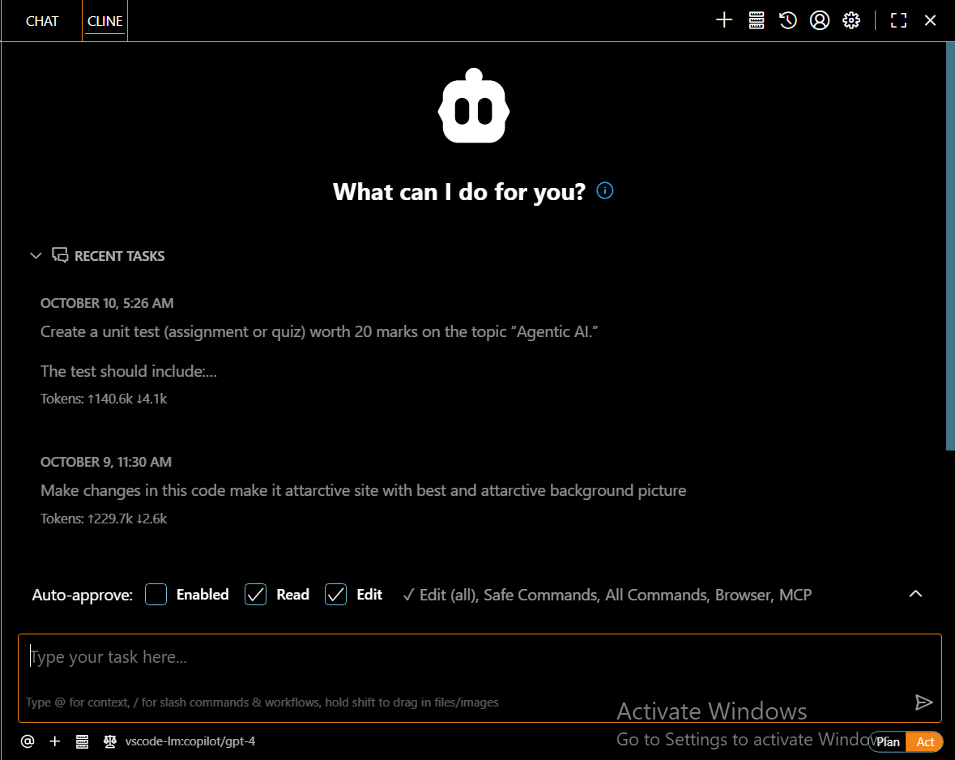
ACT/Plan Mode:
• Plan Mode: Cline first analyzes your request, explains what steps it will take, and waits for your approval before making changes.
• Act Mode: Cline directly performs tasks automatically (like editing files or running commands) without asking for confirmation.

API Models:
• API Providers: Platforms like OpenAI, Anthropic, or OpenRouter that give access to powerful AI models used by tools such as Cline.
• API Keys: Unique security codes that connect your tool to the provider’s server, allowing safe communication and usage tracking.
• Functionality: They let your app or tool send requests to the AI model, get responses, and use advanced features like coding help, reasoning, or image handling — all through a secure and authorized link.

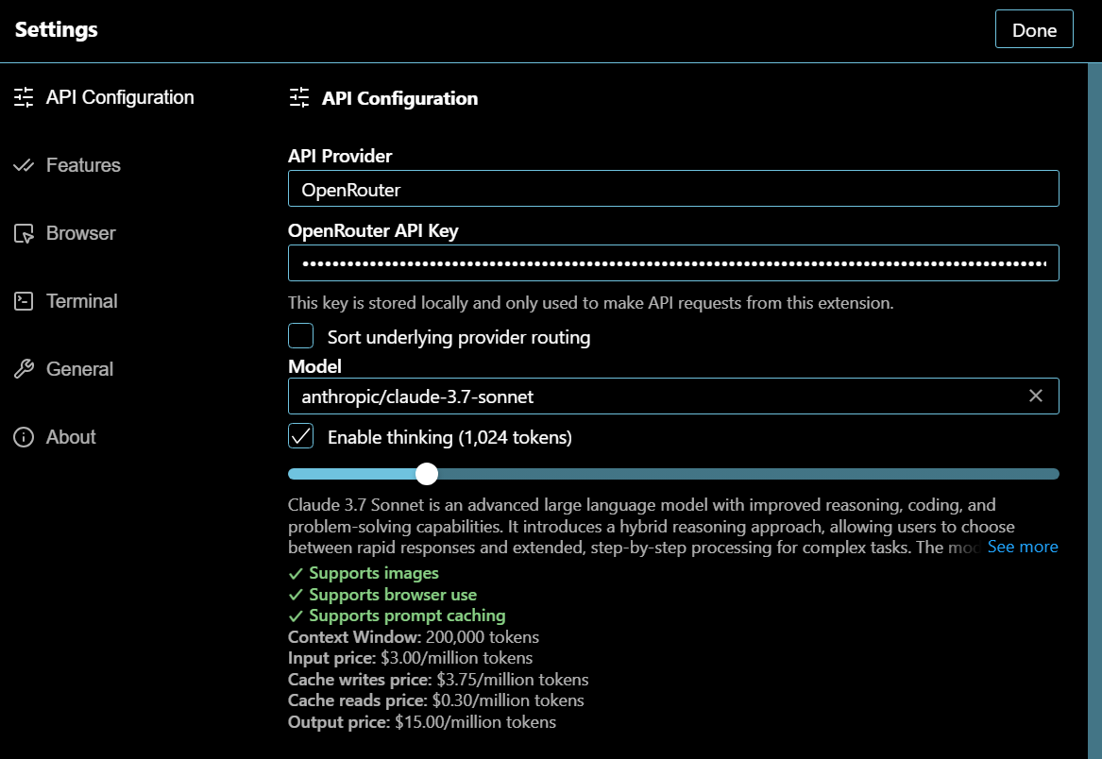
Free API keys Provider Platforms:
• OpenAI — New accounts often get small free credits to try the API; sign up and copy the key from your dashboard. AI Free API
• Hugging Face (Inference / Hub) — Free Hub account + limited free inference access for models and Spaces; get key from your profile/settings. Hugging Face
• OpenRouter — Acts as a unified gateway to many models and has developer/demo access tiers; create an account and grab the API key. OpenRouter
• Cohere — Provides a free trial API key for developers to test models; register and use the trial key from the console. Cohere
• Replicate — “Try for free” playground and per-model free/demo usage on signup; obtain the API token in your account. Replicate
• DeepAI / other small providers — Offer limited free access for basic endpoints (image/text); sign up to get an API key.
Prompt for Cline:
“Build a responsive and attractive website about core concepts of mathematics and their real-world applications in IT. The home page should have a mathematical formulas background image, short sections on key math topics, and how they are used in programming, AI, data science, and cybersecurity. Use modern UI, smooth navigation, and make it user-friendly and visually appealing.
Integrating documentation or test generation via Cline
Cline can automatically create documentation or tests for your code by analyzing functions, classes, and logic — saving time and improving accuracy.
Prompt Example (for test generation):
“Generate unit tests for this Python project using pytest, covering all main functions and edge cases.”
Comparing Cline vs. Copilot (scope, control, depth)
• Scope:
- Cline works across the entire project, reading and editing multiple files.
- Copilot focuses mainly on single-file code suggestions.
• Control:
- Cline lets you review and approve every AI change before applying.
- Copilot applies suggestions instantly as you type.
• Depth:
- Cline performs complex reasoning and project-wide refactoring.
- Copilot gives quick code completions and short hints
Advantages and disadvantages:
Advantages:
- Handles whole-project reasoning.
- Allows review before applying changes.
- Supports multi-file edits, tests, and docs.
- Works with various AI models via API.
Disadvantages:
- Needs internet and API setup.
- Can be slower for large projects.
- Limited offline use.
- May make minor coding errors, requiring review.
Summary
So, to wrap up — today we learned how Agent-Based and Agentic AI Programming helps create systems that can think, decide, and act on their own.
We explored Cline, a smart AI tool inside VS Code that helps developers write, test, and edit code with the support of intelligent agents.
You saw how to install and use Cline, its Plan and Act modes, and how it connects with API providers and keys to access powerful AI models.
We also discussed how Cline can generate documentation, create tests, and manage full projects, giving us more control than tools like GitHub Copilot.
In short, Cline makes coding smarter, faster, and more interactive, showing how AI and programming are now working hand in hand.
Closing Line:
I hope this session helped you understand how Agentic AI and tools like Cline are shaping the future of programming and automation. Thank you!

ALLAH HAFIZ

